Inventory System for Medical Laboratory Instruments



A Project Presented in Partial Fulfilment of the Requirements for the Degree
Bachelor of Science in Information Technology

Presented by:

Daniella Marie C. Bello
Alexa Fame S. Macalos
Jayquio M. Lagrama

Mr. Ryan Billera
SIA Adviser

November 2025

Inventory System for Medical Laboratory Instruments

Prepared by:

Daniella Marie C. Bello
Alexa Fame S. Macalos
Jayquio M. Lagrama

Adviser:
Ryan Billera

had been approved
Oct 2, 2025

Approving Committee

Name | Role | Signature
 | Panel
 | Panel
 | Panel

Accepted by:
JANETTE M. CLARO

OIC Dean, College of Information Technology Education
Jose Maria College Foundation Inc.

APPROVAL SHEET
Inventory System for Medical Laboratory Instruments |  |  | Date Submitted: Nov 13, 2025
Name of Proponents: Alexa Fame S. Macalos, Daniella Marie C. Bello, Jayquio M. Lagrama
Brief Description of the Project:
In many medical laboratories, the process of managing and tracking instruments is still performed manually using logbooks or spreadsheets. This traditional approach often leads to human error, missing data, and time-consuming record retrieval. It also makes it difficult to monitor instrument conditions, calibration schedules, and usage histories.
Main goal of the system is to:
The main purpose of this project is to develop a user-friendly inventory system that can handle and organize data related to medical laboratory instruments. The system will help laboratory personnel record details such as instrument name, quantity, status, and maintenance history. It will also include search and reporting features to make management more efficient. The proposed system will provide a reliable platform for storing data, reducing manual workload, and ensuring that laboratory instruments are properly monitored and maintained.
APPROVED BY:
Mr. Ryan Billera
Adviser

_______________________ _______________________ _______________________
(Name) (Name) (Name)
Panel Member Panel Member Panel Member

ACKNOWLEDGMENTS

The researchers would like to express their heartfelt gratitude to Mr. Ryan Billera for the guidance and support throughout this study. Sincere thanks are also extended to the panel members and respondents for their valuable time and contributions. Special appreciation goes to our families and friends for their constant encouragement and understanding. Above all, we thank Almighty God for the wisdom and strength to complete this research.

TABLE OF CONTENTS

TITLE PAGE …………………………………………………… 1
APPROVAL SHEET…………………………………………… 3
ACKNOWLEDGMENTS …………………………………… 3
ABSTRACT …………………………………………………… 7
CHAPTER I - INTRODUCTION
Background of the Study ……………………………… 7
Statement of the Problem ……………………………… 7
Objectives …………………………………………… 8
Significance Of the Study ……………………………… 8
Scope and Limitations …………………………………… 8
Definition of Terms ……………………………………… 9
CHAPTER II - REVIEW OF RELATED LITERATURE 9
CHAPTER III - PRESENTATION AND ANALYSIS OF THE EXISTING SYSTEM
The Existing System ………………………………………… 10
Scope …………………………………… 11
Concept of Operations …………………………… 11
CHAPTER IV - FEASIBILITY ANALYSIS
Operational Feasibility…………………… 12
Technical Feasibility…………………………………… 12
Economic Feasibility (Cost-Benefit Analysis) ………… 12
Legal and Ethical Feasibility……………………………… 12
Organizational Feasibility ……………………………… 13
CHAPTER V - SYSTEM ARCHITECTURE REVIEW
Adopted Architecture…………………………………… 13
Architectural Diagram …………………………………… 14
Conceptual Flow Diagram ……………………………… 14
Component Description ………………………………… 14
Design Rationale ………………………………………… 14
CHAPTER VI - SYSTEM INTEGRATION DESIGN
Integration Objectives…………………………………… 15
Integration Approach …………………………………… 15
Integration Architecture Diagram ……………………… 15
Data Flow Diagrams (DFD) ……………………………… 16
Interface Specifications …………………………………… 16
SYSTEM DESIGN AND IMPLEMENTATIONS
Database Design ………………………………………… 17
User Interface Design …………………………………… 17
Integration Implementation ……………………………… 19
Tools and Platforms ……………………………………… 19
REFERENCES …………………………………………………… 19

Inventory System for Medical Laboratory Instruments

ABSTRACT
The management of medical laboratory instruments within academic and healthcare environments has traditionally relied on manual methods such as logbooks and spreadsheets, resulting in inefficiencies, data inaccuracy, and increased human error. This study aims to design and develop a digital inventory management system that automates the processes of tracking, monitoring, and reporting medical laboratory instruments. The primary objective is to establish a centralized, secure, and user-friendly platform that enables authorized personnel to efficiently manage instrument records, monitor availability and condition status, and generate accurate reports for operational decision-making.
The system development follows the Agile methodology, encompassing iterative phases of requirements analysis, database and interface design, implementation, and testing. The results will be presented through quantitative performance metrics and qualitative user satisfaction analyses, demonstrating enhanced operational efficiency, accuracy, and user experience.
Initial evaluations indicate a substantial reduction in manual workload and human error, alongside improved reliability and accessibility of instrument data. In conclusion, the proposed system provides a significant technological advancement in laboratory resource management, promoting effective maintenance practices and supporting the delivery of accurate and reliable laboratory outcomes essential to both education and patient care.
1. Background of the study
In medical laboratory operations, accurate instrument management is crucial to ensure reliable diagnostic results and maintain operational efficiency. However, many institutions continue to depend on manual record-keeping methods such as logbooks and spreadsheets to track the usage, condition, and maintenance of laboratory instruments. While these methods can manage small-scale operations, they often lead to inefficiencies, human errors, and delays in data retrieval and reporting as the number of instruments increases.
At Jose Maria College Medical Technology Laboratory, the management of laboratory instruments still relies on manual logging and spreadsheet-based monitoring. This traditional process has resulted in issues such as inaccurate inventory records, difficulty in tracking instrument availability and maintenance history, and time-consuming report generation. These challenges hinder effective laboratory management and increase the risk of operational disruptions.
To address these concerns, this study proposes the Inventory Management System for Medical Laboratory Instruments, a digitalized platform designed to automate the recording, tracking, and reporting processes. The system aims to enhance data accuracy, ensure real-time monitoring of instruments, and streamline maintenance scheduling. By automating these core functions, the proposed system is expected to improve efficiency, reduce manual workload, and support more reliable laboratory operations at Jose Maria College.
2. Statement of the Problem
Despite the critical role of instruments in medical laboratory operations, many laboratories continue to rely on manual methods for managing their equipment. This outdated approach poses several problems that hinder effective laboratory management. These include:
- Inaccurate and inconsistent data recording – Manual entry increases the likelihood of human errors, leading to incorrect information about instrument status, quantity, or maintenance history.
- Difficulty in data retrieval and monitoring – Using logbooks or spreadsheets makes it time-consuming to search for specific instrument information, especially when handling large datasets.
- Lack of timely maintenance tracking – Without an automated reminder system, laboratories may overlook calibration schedules or maintenance dates, potentially compromising instrument performance and test accuracy.
- Limited reporting and data analysis capabilities – Manual systems make it difficult to generate accurate and up-to-date reports for management and regulatory compliance.
3. Objectives Of The Study

General Objective:
The main purpose of this study is to design and develop an automated inventory management system that will improve the efficiency, accuracy, and accessibility of medical laboratory instrument records at Jose Maria College Medical Technology Laboratory. The proposed system seeks to address the limitations of the existing manual process by providing a centralized digital platform for recording, tracking, and managing laboratory instruments.

Specific Objectives:

1. Design a structured database for storing, updating, and managing instrument information.
2. Develop CRUD (Create, Read, Update, Delete) functionalities to enable efficient record management.
3. Implement a secure user authentication module to ensure authorized access and protect data integrity.
4. Generate automated inventory, maintenance, and availability reports for effective monitoring and decision-making.
5. Evaluate the system’s usability, functionality, and performance based on feedback from laboratory personnel.

4. Significance of the study
The proposed Inventory System for Medical Laboratory Instruments aims to enhance efficiency, accuracy, and accessibility in managing laboratory equipment. By automating tracking and monitoring processes, the system directly benefits the following stakeholders:
Laboratory Administrators:
The system provides real-time updates on instrument availability, usage, and maintenance schedules, enabling better tracking, planning, and decision-making. Automated reports simplify compliance with institutional and regulatory requirements, reducing administrative workload.
Faculty and Laboratory Staff:
The system offers an efficient platform for updating instrument records and scheduling maintenance or calibration. This ensures that all equipment is functional, reduces the risk of errors, and supports smooth laboratory operations.
Students:
The system allows students to easily view instrument availability and borrowing records. With transparent and up-to-date information, students can plan laboratory activities more efficiently and experience a more organized learning environment.
The Institution:
Implementing the system supports digital transformation and operational modernization. It promotes efficient resource management, data integrity, and innovation in laboratory practices. The system can also serve as a model for improving other institutional processes.
Overall:
This study contributes to improving laboratory management by providing a reliable, user-friendly, and automated solution that minimizes manual work, enhances productivity, and strengthens institutional efficiency.
5. Scope and Limitations
5.1 Scope
This study focuses on the development of an Instrument Monitoring System aimed at assisting laboratory personnel in efficiently managing and tracking medical laboratory instruments at Jose Maria College Medical Technology Laboratory. The system is designed to support laboratory operations by providing the following functionalities:
- CRUD (Create, Read, Update, Delete) operations for instrument records.
- Real-time tracking of instrument availability and condition.
- User account registration and authentication to ensure secure and authorized access.
- Automated report generation covering inventory, usage, and maintenance records.
- Dashboard summary displaying total instruments, available units, and maintenance alerts for quick monitoring.
The system is intended for use within the laboratory’s local network and exclusively for authorized personnel. Its focus is limited to instrument management and monitoring, establishing clear project boundaries and ensuring the study remains concentrated on laboratory operational processes.
5.2 Limitations
Despite its features and capabilities, the system has the following limitations:
- It does not include barcode or RFID scanning integration.
- It does not process financial transactions or procurement activities.
- It is restricted to local network access only and does not support cloud-based or remote access.
6. Definition of Terms

This section defines key technical terms used in the study to ensure clarity and uniform understanding. The definitions are specific to the proposed Instrument Monitoring System at Jose Maria College Medical Technology Laboratory.
CRUD (Create, Read, Update, Delete) - Refers to the four fundamental database operations utilized by the system to efficiently manage laboratory instrument records.
Inventory - The digital record of all laboratory instruments, including their availability, condition, usage history, and maintenance status, as tracked and maintained by the system.
Calibration - The process of verifying and adjusting laboratory instruments to ensure accurate measurements, with schedules and records monitored and managed within the system.
Maintenance - Periodic inspection, servicing, or repair of laboratory instruments to maintain optimal performance, tracked systematically by the proposed system.
Dashboard - A graphical user interface within the system that provides a real-time summary of instrument status, availability, and maintenance alerts to laboratory personnel.
User Authentication - A security mechanism implemented in the system to verify authorized access, ensuring that only permitted personnel can view, add, or modify instrument records.
Automated Report Generation - The system’s functionality that allows the automatic creation of comprehensive reports on instrument inventory, usage, and maintenance schedules, eliminating the need for manual calculations.

7. Review Related Literature and System
7.1 Related Literature
Digital Inventory Systems and Automation
Several studies highlight the advantages of digital inventory management systems in improving operational efficiency and data accuracy. According to Plinere and Borisov (2015), the automation of inventory processes significantly minimizes human error and enhances real-time data tracking, allowing institutions to make informed decisions more efficiently. Similarly, Noveda, Yu, Verecio, and Anade (2023) emphasize that digital inventory systems provide timely updates, improve data reliability, and streamline resource management, which are essential in educational and institutional environments.
Information System Change Control
Effective change management within information systems is crucial for maintaining data integrity and ensuring consistent performance. Research by Adekunle et al. (2024) demonstrates that automated and structured systems support accurate monitoring of operational processes and reduce inconsistencies that arise from manual record-keeping. These systems also provide a foundation for future scalability and integration with other institutional applications.
Digital Transformation in Laboratory Operations
Digital transformation plays a vital role in modernizing laboratory operations. Abude (2021) notes that the introduction of computerized systems in government laboratories under the Bureau of Soils and Water Management (BSWM) improved operational transparency, reduced administrative workload, and enhanced the reliability of laboratory data. This transition reflects the growing importance of automation in supporting laboratory productivity and accountability.
In summary, related literature supports that automation and digital transformation are critical in improving data accuracy, efficiency, and transparency. However, many of these studies focus on general supply or institutional inventory systems rather than those specifically tailored for medical laboratory instruments, where precision and calibration tracking are vital.
7.2 Related Systems
National Systems
The Supply Inventory Management System developed for Leyte Normal University (Noveda et al., 2023) showcases the effectiveness of automation in institutional inventory control. It allows administrators to monitor supply levels, track usage history, and generate reports efficiently. While the system significantly improved data accuracy and time management, its functions focus primarily on office and educational supplies rather than specialized laboratory instruments that require maintenance and calibration tracking.
Global Systems
The Web-Based Laboratory Management System (WBLMS) created for the ICT Laboratory at the Federal Polytechnic, Ile-Oluji (Adekunle et al., 2024) provides comprehensive monitoring of laboratory resources, including borrowing records, inventory tracking, and real-time updates. The system’s success demonstrates the practicality of web-based management in academic settings. However, it lacks dedicated modules for instrument maintenance or calibration reminders, which are crucial in medical laboratories.
The Laboratory Information Management System (LIMS) developed by the Bureau of Soils and Water Management (Abude, 2021) integrates data collection, analysis, and reporting for laboratory samples. Although it focuses on agricultural laboratory workflows, it offers valuable insights into how centralized digital systems can streamline data handling and improve reporting efficiency.

2.3 Synthesis
The reviewed literature and systems consistently show that digital automation enhances operational efficiency and data reliability across various institutional contexts. However, most existing systems are designed for general supply or information management rather than for medical laboratory instruments, which demand precise condition tracking, maintenance scheduling, and calibration management.
This research bridges that gap by designing a specialized Inventory System for Medical Laboratory Instruments that combines inventory tracking, maintenance logging, and user role management in one centralized platform. The proposed system tailors the proven advantages of automation to meet the unique operational requirements of medical laboratories.
8. The Existing System
The researchers conducted an in-depth assessment of the existing manual system used for managing laboratory instruments at Jose Maria College in Medical Technology Laboratory. This evaluation involved direct observation of laboratory operations, interviews with laboratory staff, and feedback collection from users to identify the inefficiencies and challenges of the current process.
At present, the management of instruments relies on manual record-keeping using logbooks. Laboratory personnel are responsible for recording information such as instrument names, conditions, and availability status by hand. While this traditional approach allows basic documentation, it poses numerous limitations in terms of accuracy, efficiency, and accessibility.
The current manual process makes it difficult to track the real-time status and condition of instruments, often resulting in errors or missing information. Retrieving data for reports or maintenance schedules takes considerable time, especially when searching through multiple records. Additionally, physical records are prone to damage, loss, or human error during data entry. These issues lead to delays in equipment allocation, hinder proper maintenance tracking, and reduce overall laboratory productivity.
Given these challenges, there is a clear need for an automated system that can streamline instrument management, ensure data accuracy, and facilitate faster monitoring, reporting, and decision-making within the laboratory setting.

9. Scope
This research aims to evaluate the existing manual system for managing laboratory instruments at Jose Maria College Medical Technology Laboratory and design an automated instrument management system to address the inefficiencies in the current process. The study focuses on improving the accuracy, efficiency, and accessibility of instrument management through automation.
9.1 Data Collection:
● Observations and Interviews: Direct observations and interviews with laboratory staff to identify inefficiencies in the current manual system.
● Record Analysis: Examination of existing logbooks to quantify issues like time delays, data entry errors, and difficulties in generating reports or scheduling maintenance.
9.2 Challenges Identification:
● Identify specific challenges related to tracking the real-time status and condition of instruments, which impacts equipment allocation, maintenance tracking, and laboratory productivity.
9.3 System Design:
● Functional Requirements: Define essential features for the automated system, such as real-time tracking, data entry forms, maintenance scheduling, and reporting.
● System Architecture: Design the system architecture to ensure efficient management, easy data input, and quick retrieval.
9.4 Development of the Automated System:
● Prototyping: Develop a working prototype or pilot version of the automated system to test its functionality.
● Implementation: Deploy the system in the laboratory, ensuring it integrates smoothly into daily operations and replaces the manual logbook system.
9.5 System Evaluation:
● Performance Analysis: Compare system performance before and after implementation, focusing on time efficiency, data accuracy, and ease of report generation.
● User Feedback: Collect feedback from laboratory staff on their experiences with the system, including usability and its impact on productivity.
9.6 Impact on Laboratory Operations:
● Time and Efficiency Gains: Measure the reduction in time spent on tasks like data entry, instrument tracking, and report generation.
● Accuracy and Accessibility: Assess the improvement in the accuracy of records and how easy it is for staff to access up-to-date information on instrument conditions and maintenance.
10. Concept of Operation
10.1 Instrument Management Procedure

Manual Recording:
Laboratory personnel currently record instrument details such as name, model, availability, and condition in paper logbooks or spreadsheets. Each time an instrument is borrowed or returned, staff members manually write down the borrower’s name, date, and purpose of use. This process is time-consuming and often results in incomplete or inaccurate entries. During busy laboratory hours, delays frequently occur as multiple users wait to record their transactions, leading to confusion and difficulty in tracking instrument availability.
Condition Monitoring:
The condition of each instrument is noted only during manual inspections, which are done periodically rather than in real time. Staff members depend on handwritten notes or memory to track maintenance schedules and identify instruments that need repairs. This method increases the likelihood of overlooking damaged equipment or missing scheduled maintenance, potentially affecting the quality and safety of laboratory operations.
Data Compilation and Reporting:
At the end of each week or month, laboratory staff manually compile data from the logbooks to prepare usage and maintenance reports. This process requires sorting through numerous handwritten entries, which is prone to errors and inconsistencies. Generating accurate and timely reports becomes difficult, delaying the decision-making process regarding instrument replacement, repairs, and utilization analysis.
These challenges highlight the need for an automated system that simplifies the tracking process, ensures real-time monitoring of instrument status, and provides reliable and easily retrievable data for efficient laboratory management.

11. Methodology, Result and Discussion
11.1 Operational Feasibility

Operational feasibility evaluates how well the proposed Instrument Management System will operate within the laboratory setting and how effectively it will address the limitations of the existing manual process. It determines whether the system can be successfully integrated into daily laboratory operations and accepted by its intended users.
The current manual method of recording and monitoring laboratory instruments relies on paper-based logbooks and manual data entry, which often leads to errors, time delays, and inefficiency. The proposed automated system aims to resolve these problems by introducing a centralized and user-friendly platform for managing instrument records, monitoring availability, and generating maintenance reports.
The system is designed to be intuitive and simple to operate, ensuring that laboratory personnel, even those with minimal technical background, can navigate it easily. It features secure authentication to protect data and restrict access to authorized users only. Through automated processes such as record management, report generation, and real-time instrument monitoring, the workload of laboratory staff will be significantly reduced.
Additionally, implementing the system will not require major workflow changes. Basic training and documentation will help ensure a smooth transition from manual to digital operations. Thus, the Instrument Management System is deemed operationally feasible, as it enhances efficiency, minimizes errors, and improves data reliability in laboratory operations.
11.2 Technical Feasibility
Technical feasibility assesses whether the current technological infrastructure and resources are sufficient to develop, implement, and maintain the proposed system.
The Instrument Management System will be developed using open-source technologies such as HTML, CSS, JavaScript, PHP, and MySQL. These technologies are well-supported, reliable, and compatible with most hardware and software configurations commonly found in academic institutions. MySQL provides a robust database structure for storing and retrieving instrument data, while PHP ensures efficient server-side processing.
The system can operate on standard desktop computers or laptops with a stable internet connection and does not require specialized hardware. It can be hosted on a local server within the institution or an online platform, depending on the available infrastructure. The development team possesses adequate technical skills to design, test, and deploy the system successfully. Furthermore, the availability of online support and documentation for these technologies enhances maintainability and troubleshooting.
Given the compatibility of the technologies used and the technical capabilities of the development team, the proposed Instrument Management System is considered technically feasible.

11.3 Economic Feasibility
Economic feasibility, or cost-benefit analysis, examines whether the financial benefits of implementing the proposed system outweigh its costs.
The Instrument Management System is designed to be cost-effective by utilizing open-source tools and existing laboratory computers, eliminating the need for expensive proprietary software or hardware upgrades. The primary expenses include minimal development costs, system testing, and staff training.
Estimated Costs:
- System Development and Design – minimal (handled by researchers/developers)
- Testing and Deployment – minimal to moderate
- Training and Documentation – minimal
- Maintenance – low (periodic updates and backups)
Expected Benefits:
- Reduced administrative workload for laboratory personnel
- Faster and more accurate data retrieval
- Lower risk of data loss or record duplication
- Improved monitoring and scheduling of instrument maintenance
- Enhanced decision-making through real-time reports
The benefits gained from increased efficiency, time savings, and data accuracy outweigh the modest costs of development and implementation. Therefore, the project is deemed economically feasible.
11.4 Legal and Ethical Feasibility
Legal and ethical feasibility ensures that the proposed system adheres to institutional policies, data protection standards, and ethical principles in system use.
The Instrument Management System will comply with relevant data privacy laws such as the Data Privacy Act of 2012 (Republic Act No. 10173), ensuring that user and instrument data are stored and processed securely. The system’s authentication features will prevent unauthorized access and misuse of records.
Ethically, the system promotes transparency and accountability among laboratory users and staff. It will record all user actions, such as equipment borrowing and returning, ensuring that transactions are traceable. The development team will also ensure that no personal or sensitive data will be collected beyond what is necessary for system operations.
In conclusion, the system meets both legal and ethical requirements, making it legally and ethically feasible.

11.5 Organizational Feasibility
Organizational feasibility evaluates whether the institution has the structure, personnel, and support necessary to implement and maintain the system effectively.
The Instrument Management System aligns with the institution’s goal of modernizing laboratory operations and promoting efficiency. Laboratory personnel and administrators have expressed support for improving the current manual processes. The system fits well within the organizational structure since its operation requires only basic training and minimal supervision.
With management approval and staff cooperation, the system can be smoothly integrated into existing procedures without disrupting day-to-day laboratory activities. Regular monitoring and feedback from staff will ensure continuous improvement and sustainability of the system.
Therefore, the Instrument Management System is considered organizationally feasible, as it supports institutional goals, enhances workflow efficiency, and fosters user acceptance.
12. Adopted Architecture
The proposed Inventory System for Medical Laboratory Instruments adopts a Three-Tier Architecture model, which separates the system into three interconnected layers: the Presentation Layer, Application Layer, and Data Layer.
- Presentation Layer (Client Side): This layer is responsible for the user interface, where users such as administrators, staff, and students interact with the system. It is developed using HTML, CSS, and JavaScript to ensure responsiveness and ease of use.
- Application Layer (Server Side): This layer handles the logic and processing of user requests. It is implemented in PHP, which manages authentication, CRUD operations, and report generation.
- Data Layer (Database Server): The database layer uses MySQL to store and manage all instrument-related records, including instrument details, user information, and maintenance logs.
This architectural style promotes scalability, modularity, and maintainability, ensuring that changes in one layer do not affect others.
13. Architectural Diagram
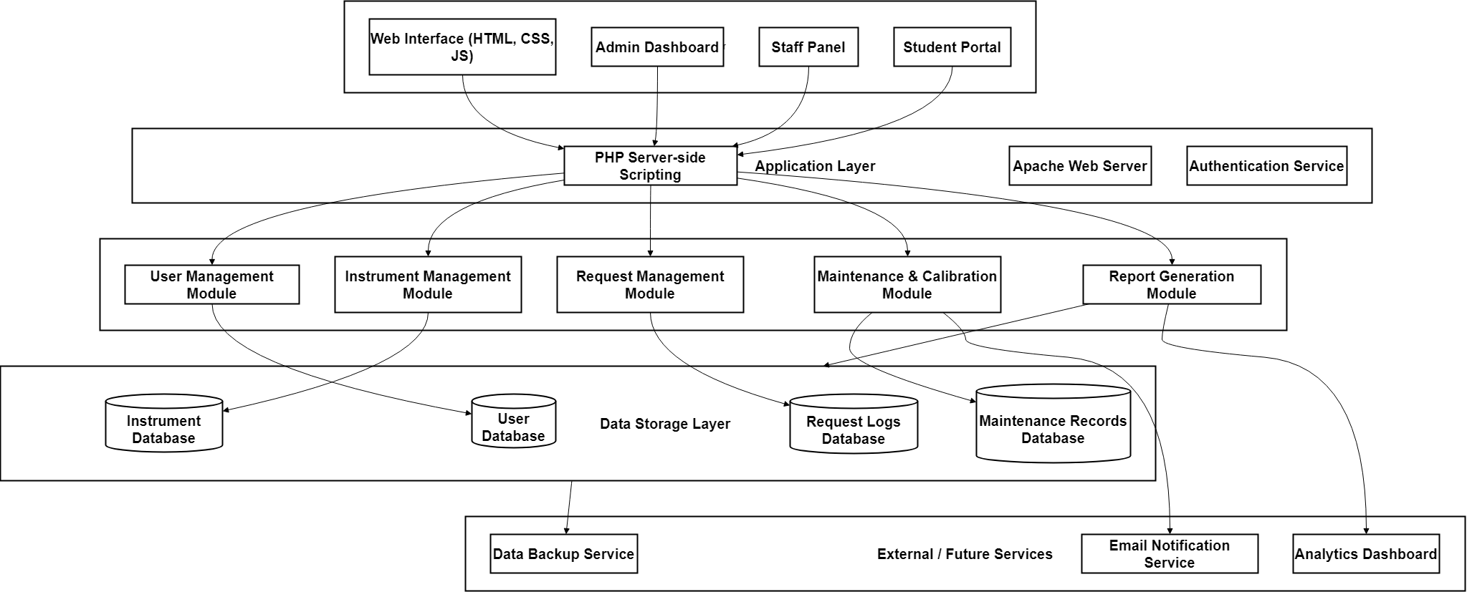
Figure 1.0 Architecture Diagram
This diagram shows the communication flow between the user interface, the web server, and the centralized database.This diagram shows the communication flow between the user interface, the web server, and the centralized database.
14. Conceptual Flow Diagram
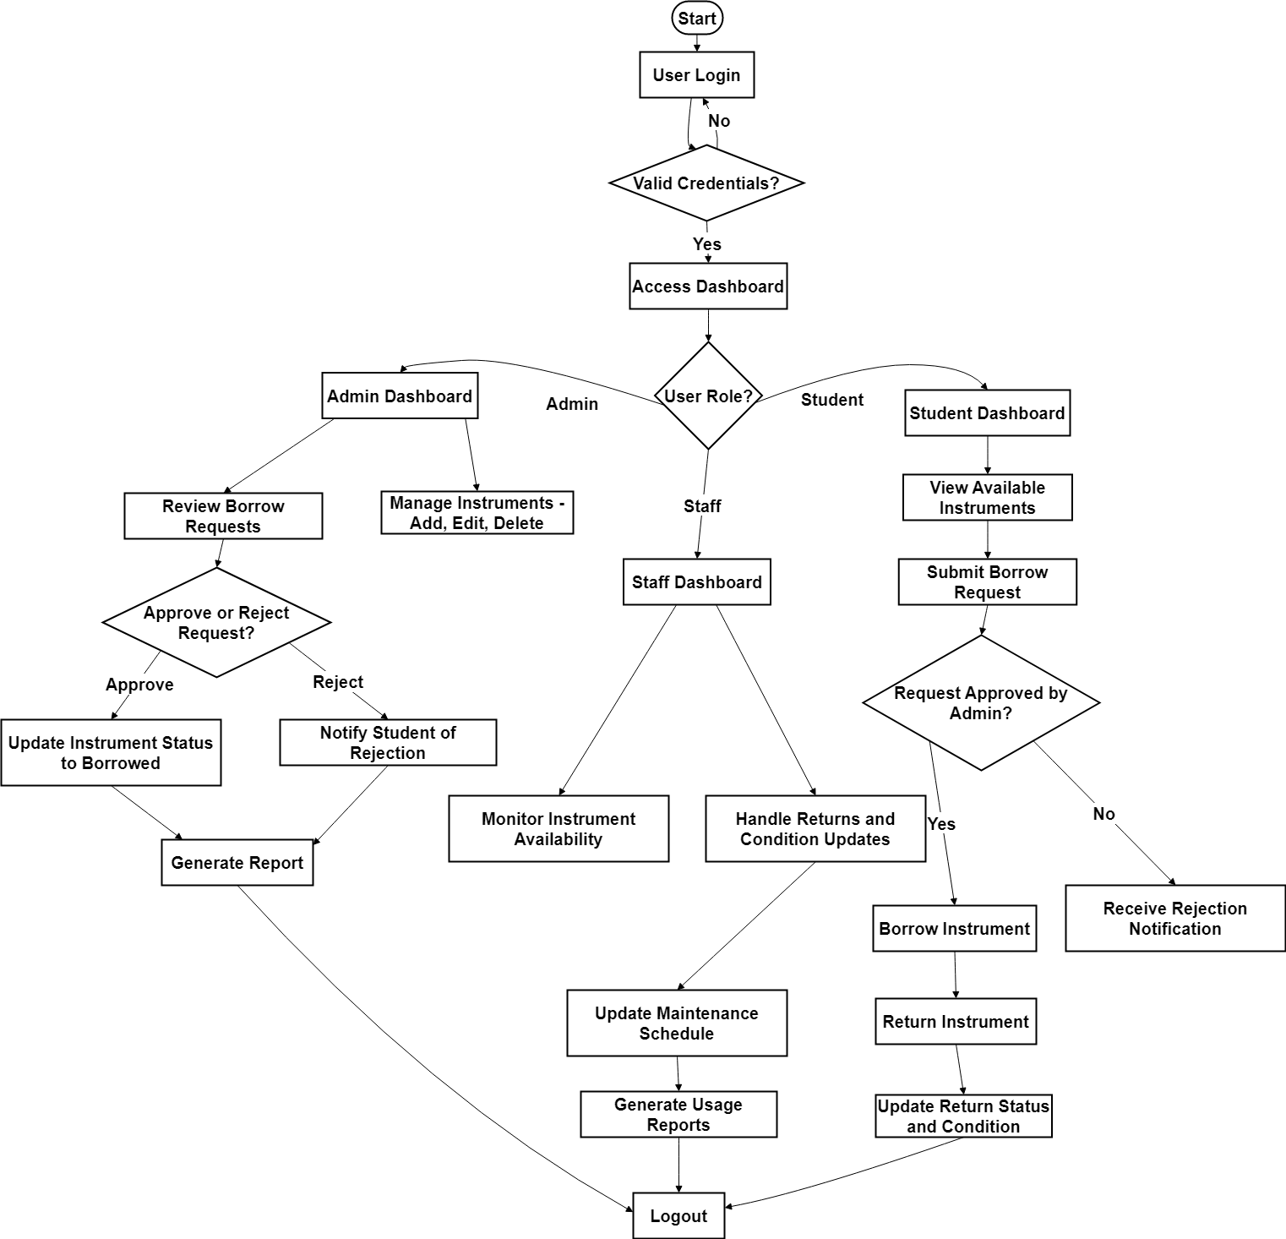
Figure 2.0 Conceptual Flow Diagram
This conceptual flow illustrates how users interact with the system, from logging in to managing instruments, processing requests, and generating reports. It also shows the flow of data between the client, server, and database.
15. Component Description
Frontend (User Interface)
- Built using HTML, CSS, and JavaScript for interactivity and responsiveness.
- Displays dynamic dashboards for each role (Admin, Staff, Student).
- Ensures intuitive navigation for tasks such as requesting, approving, or updating instrument details.
Backend (Server Logic)
- Implemented using PHP and hosted on Apache Server.
- Manages authentication, data validation, and system workflows.
- Handles CRUD operations and communication between the frontend and database.
Database (MySQL)
- Stores all system data including instrument records, users, maintenance schedules, and transaction logs.
- Utilizes relational tables with foreign keys to maintain data integrity.
- Provides data for reports and dashboards through queries.
APIs and Integrations (if applicable)
- May include future integration with calibration reminders or maintenance notifications through email or internal alerts.
- Provides extendable endpoints for connecting external modules or institutional systems.

16. Design Rationale
The design of the Inventory System for Medical Laboratory Instruments was guided by principles of simplicity, reliability, and maintainability.
- Three-Tier Architecture was selected to separate concerns and make the system easier to manage, allowing independent updates to the user interface, server logic, or database.
- PHP and MySQL were chosen for their proven compatibility, open-source availability, and ease of deployment on institutional networks.
- Modular Design ensures that each component—authentication, instrument tracking, maintenance, and reporting—functions independently yet cohesively.
- Security Considerations were implemented through user authentication and data validation to comply with the Data Privacy Act of 2012.
- Scalability was prioritized to accommodate more users and features, such as email notifications or cloud integration, in future system upgrades.
Overall, this architecture supports a user-centered, efficient, and reliable system that enhances laboratory instrument management and promotes operational efficiency.
17. Integration Objectives
The main goal of system integration is to ensure that all modules—User Management, Instrument Management, Request Management, Maintenance, and Reporting—operate cohesively as one reliable and synchronized system. Specifically, the integration aims to:
- Connect all user roles (Admin, Staff, Student) under one unified workflow.
- Ensure that every borrowing and returning transaction updates the database automatically.
- Maintain secure and accurate information flow across modules.
- Streamline the approval and monitoring process in real time.
The main goal of system integration is to ensure that all modules—User Management, Instrument Management, Request Management, Maintenance, and Reporting—operate cohesively as one reliable and synchronized system. Specifically, the integration aims to:
- Connect all user roles (Admin, Staff, Student) under one unified workflow.
- Ensure that every borrowing and returning transaction updates the database automatically.
- Maintain secure and accurate information flow across modules.
- Streamline the approval and monitoring process in real time.
18. Integration Approach
The system adopts a modular integration approach following the client-server model, where the frontend (user interface) communicates with the backend server using HTTP requests handled by PHP scripts. The backend processes these requests and interacts with the centralized MySQL database for storing, retrieving, and updating data.
The integration follows RESTful principles using standard HTTP methods:
- GET – Retrieve data from the database (e.g., viewing instruments or user accounts).
- POST – Add new records (e.g., adding an instrument or submitting a request).
- PUT – Update existing records (e.g., editing instrument details or request status).
- DELETE – Remove outdated or unnecessary data (e.g., deleting instrument entries).
This approach ensures efficient data handling, maintainability, and scalability of the system, while keeping integration logic simple and reliable.
19. Integration Architecture Diagram
The figure below illustrates how different components of the system interact with one another. Each user role (Admin, Staff, and Student) accesses the system through the client interface. All interactions pass through the application layer, which handles system logic and communicates with the MySQL database for data processing.
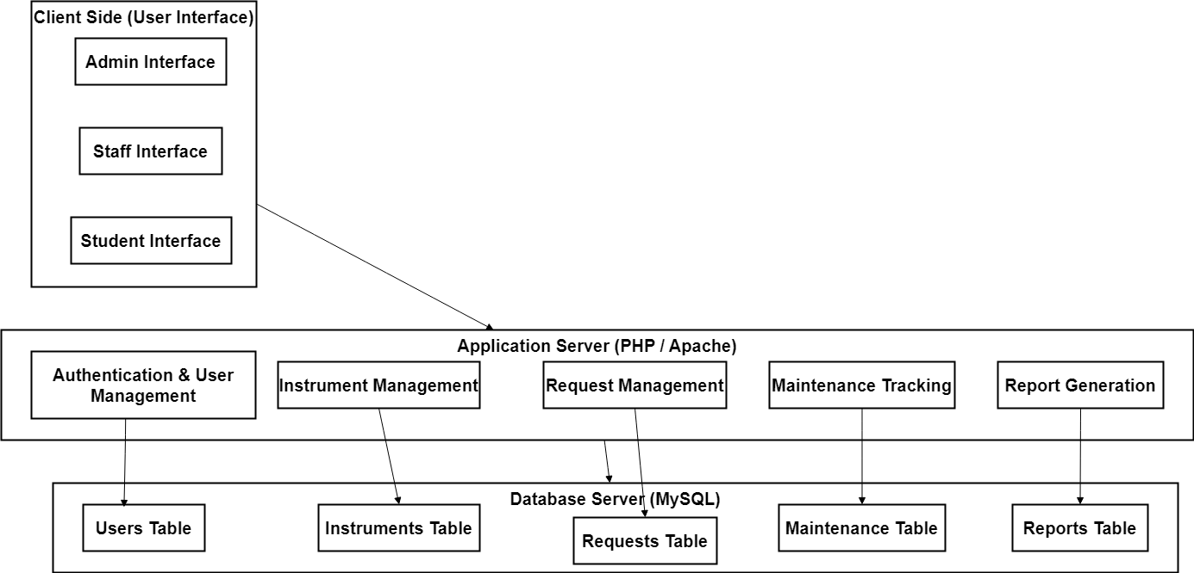
Figure 3.0 Integration Diagram

This architecture shows the system’s integrated structure and how data flows between layers through secure server-side processingThis architecture shows the system’s integrated structure and how data flows between layers through secure server-side processing.

20. Data Flow Diagrams (DFD)
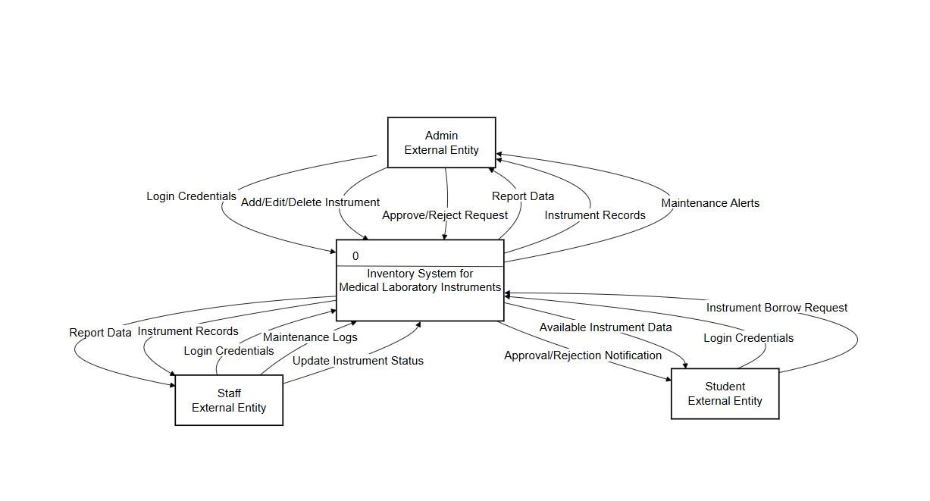
Figure 4.0 Context Diagram
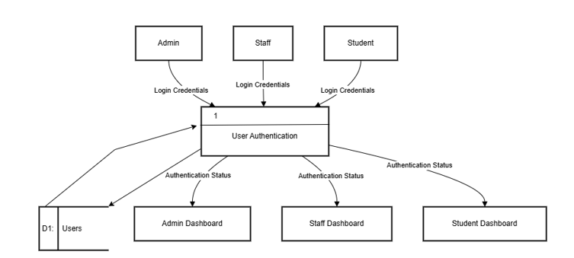
Figure 5.0 User Authentication
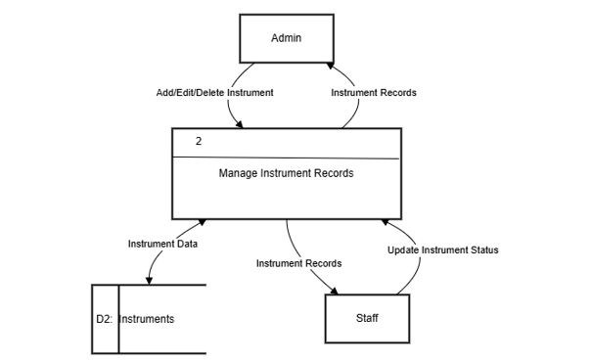
Figure 6.0 Management Instrument Record
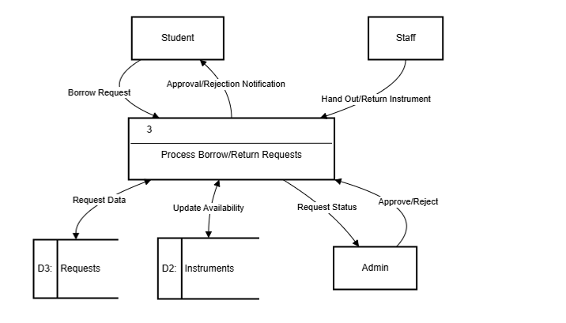
Figure 7.0 Process Borrow/Return Requests

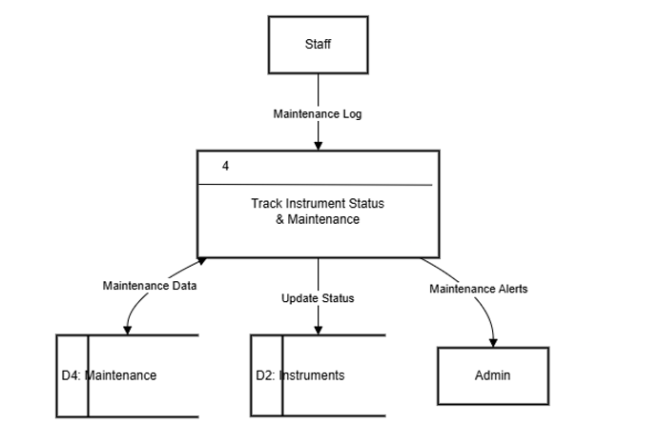

Figure 8.0 Track Instrument Status & Maintenance

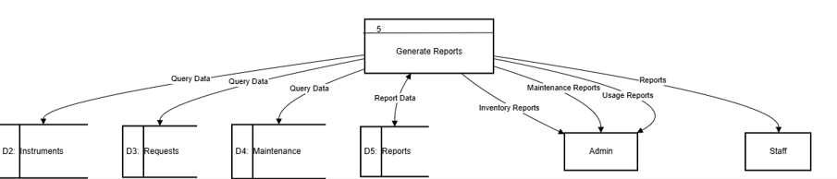

Figure 9.0 Generate Reports

21. Interface Specifications
The system uses form-based and RESTful interactions between the client and the server. Below is a sample of the API-like specifications used:

Endpoint | Description | Method | Request Parameters | Response
/login.php | Authenticates user credentials | POST | username, password | JSON: {status: success, role: admin}
/addInstrument.php | Adds new instrument record | POST | name, quantity, condition | JSON: {status: added}
/updateIstrument.php | Updates existing instrument details | PUT | instrument_id, status | JSON: {status: updated}
/getInstrument.php | Retrieves instrument list | GET | none | JSON: {data: [...]}
/requestInstrument.php | Submits instrument borrow request | POST | student_id, instrument_id | JSON: {status: pending}
Table 1.0 Interface Specification
These endpoints ensure clear communication between the frontend interface and backend server during operations.

22. System Design and Implementation
22.1 Database Design

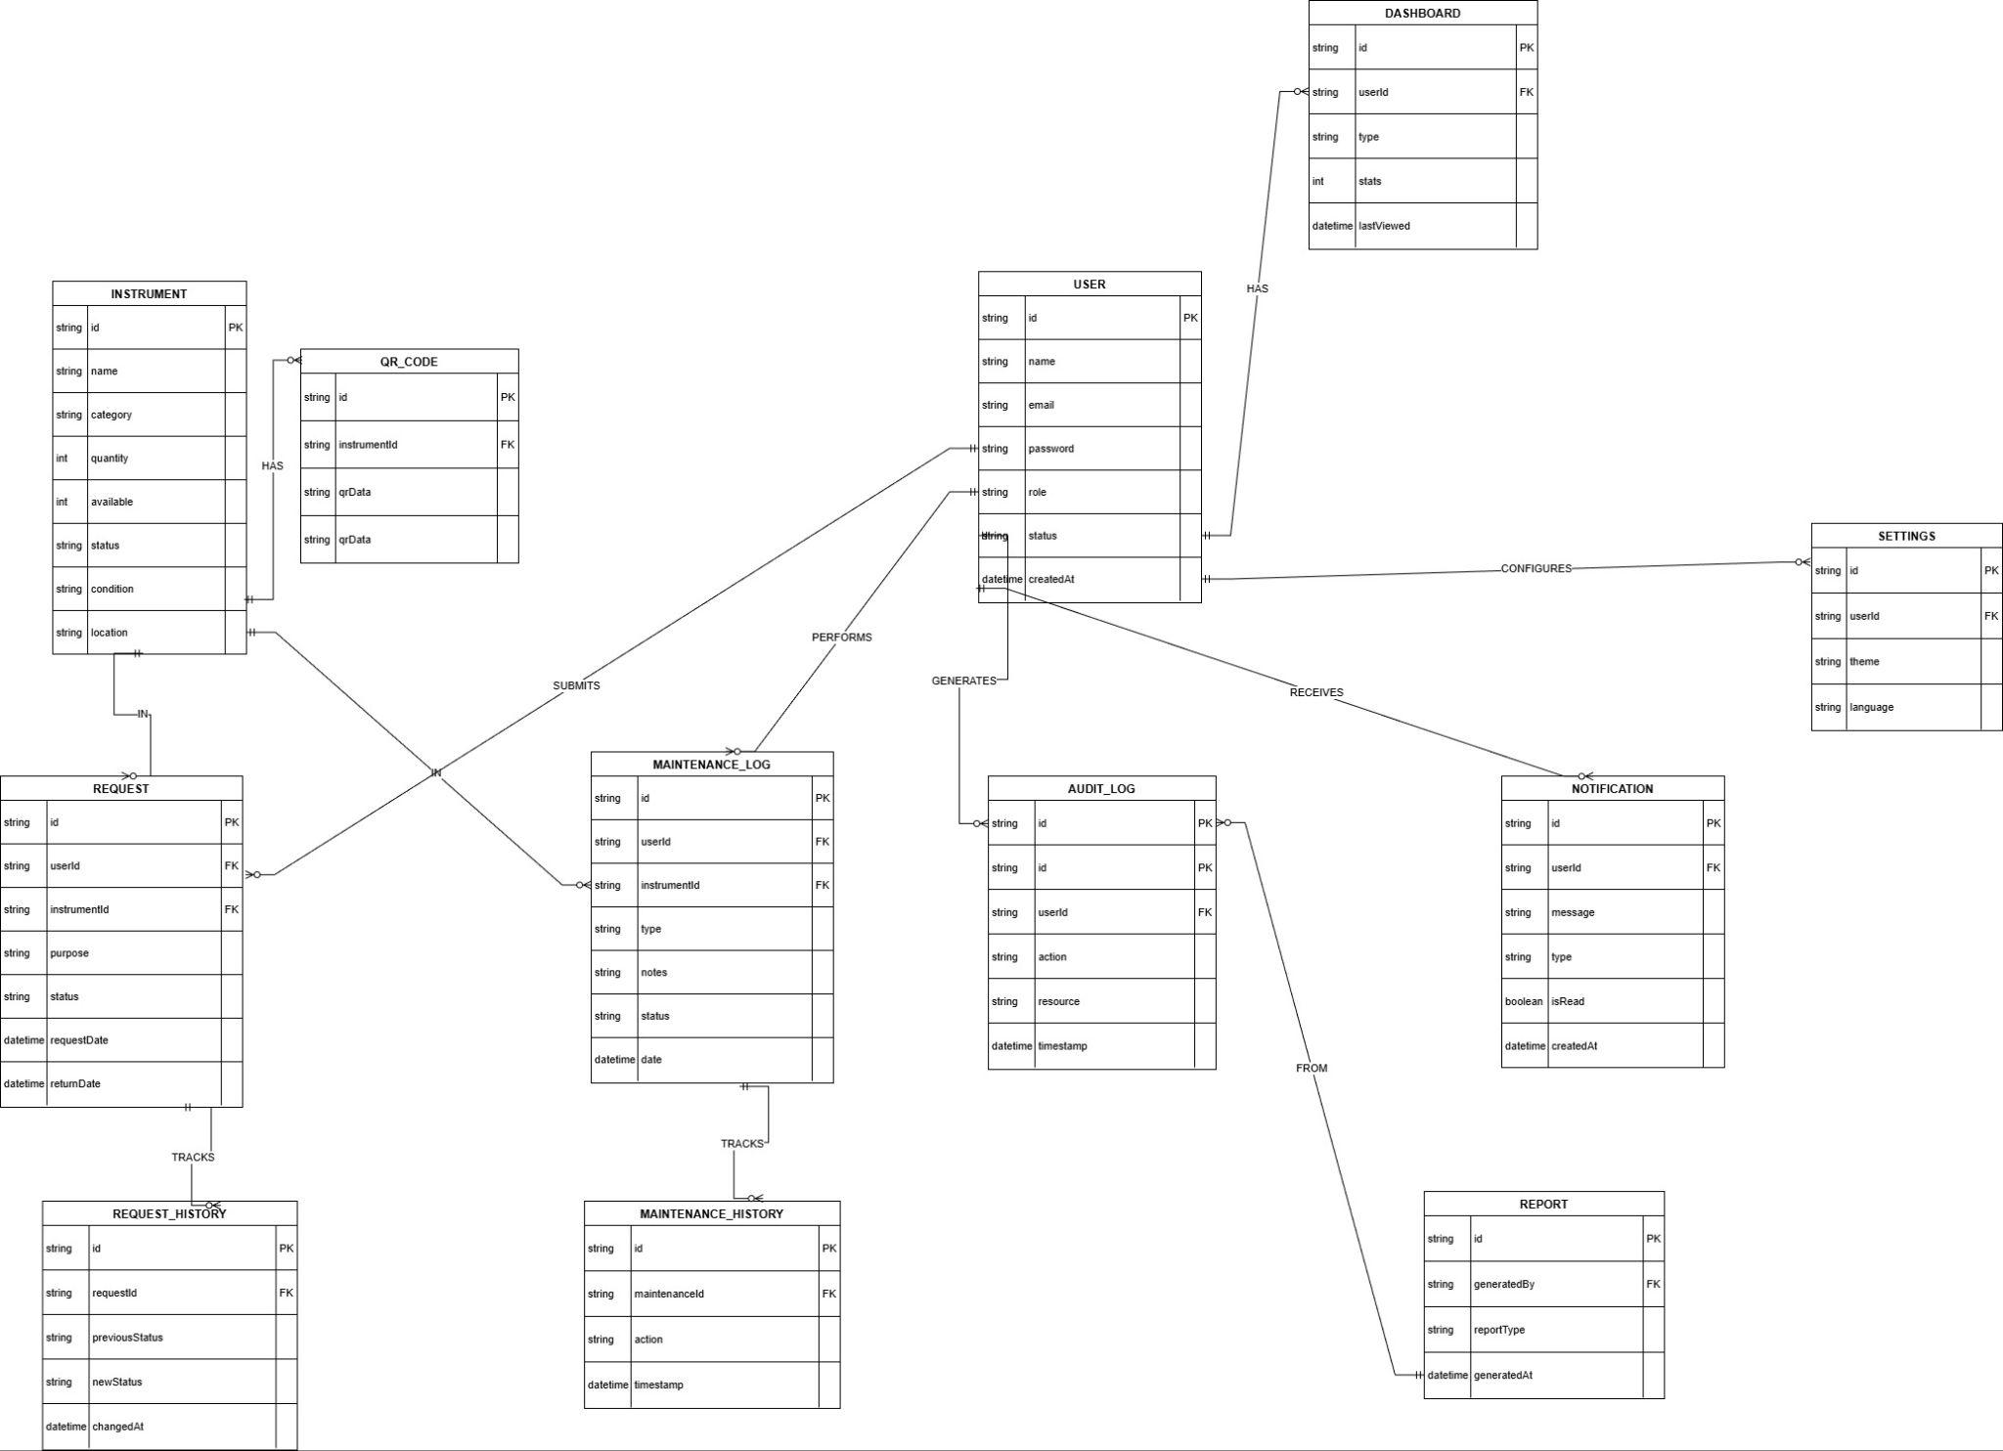
Figure 10.0 ER Diagram

This figure shows the core modules flow in our system.

The database follows a relational structure designed in MySQL.
Main Tables:
- Users - Stores login credentials and role identifiers.
- Instruments - Contains instrument names, quantities, and conditions.
- Requests - Logs borrowing and returning transactions.
- Maintenance – Tracks repair and calibration records.
- Reports – Summarizes system activity and generated logs
22.2 User Interface Design
The user interface was designed using HTML, CSS, and JavaScript to ensure simplicity and accessibility.
Each user role has a dedicated dashboard:
- Admin: Can manage all records, approve requests, and generate reports.
- Staff: Can monitor inventory, handle returns, and log maintenance activities.
- Student: Can view available instruments, submit borrow requests, and track their status.
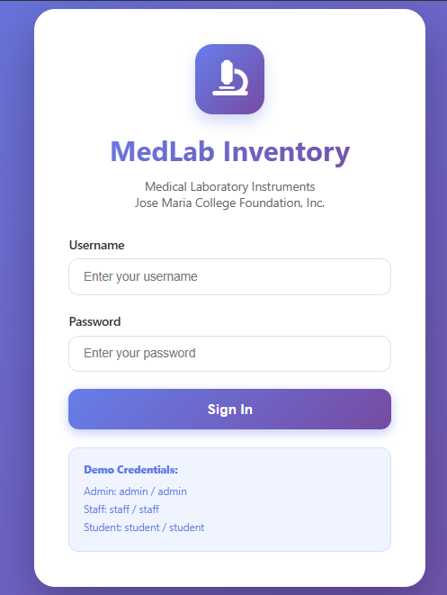Figure 11.0 Login Page
This page allows users to securely access the system by entering their registered username and password. Only authorized users such as Admin, Staff, and Students can log in to their respective dashboards.

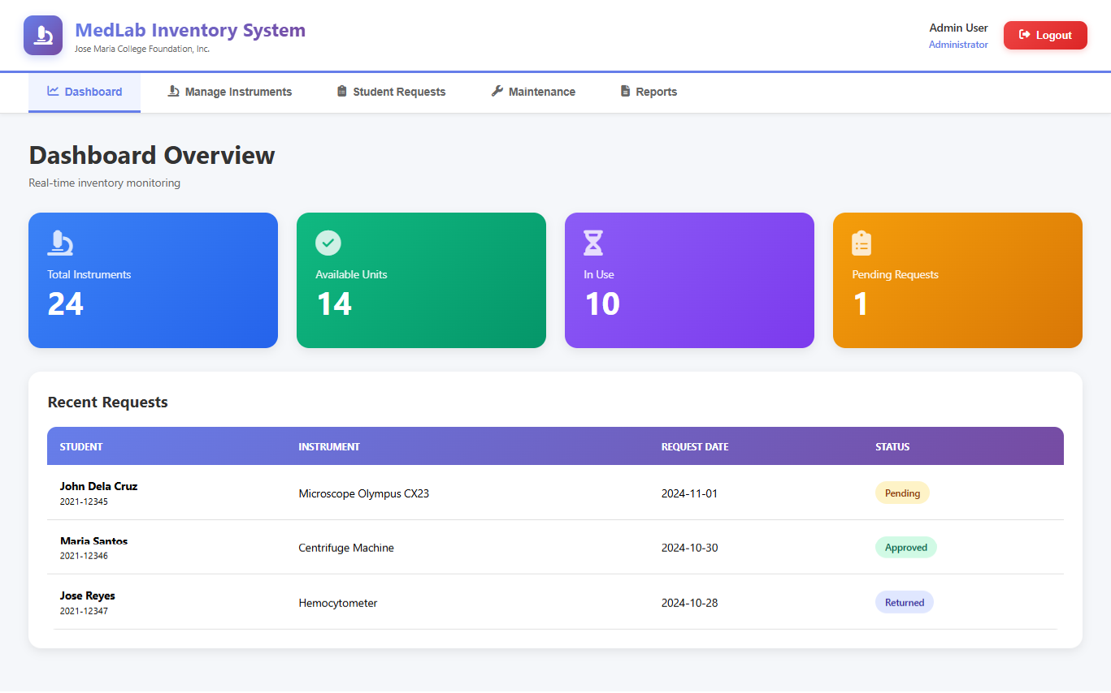
Figure 12.0 – Admin Dashboard

The admin dashboard displays an overview of system activities and provides quick access to instrument management, user accounts, requests, reports, and maintenance tools.
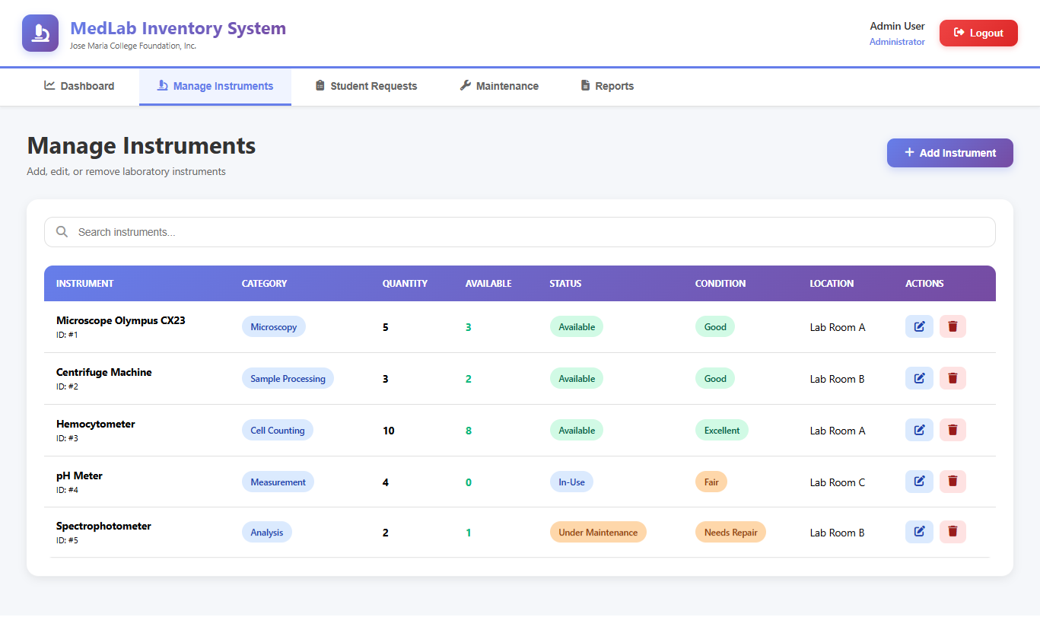
Figure 12.1 – Admin Panel: Manage Instruments

This panel allows the administrator to add, edit, update, and delete instrument records in the inventory.

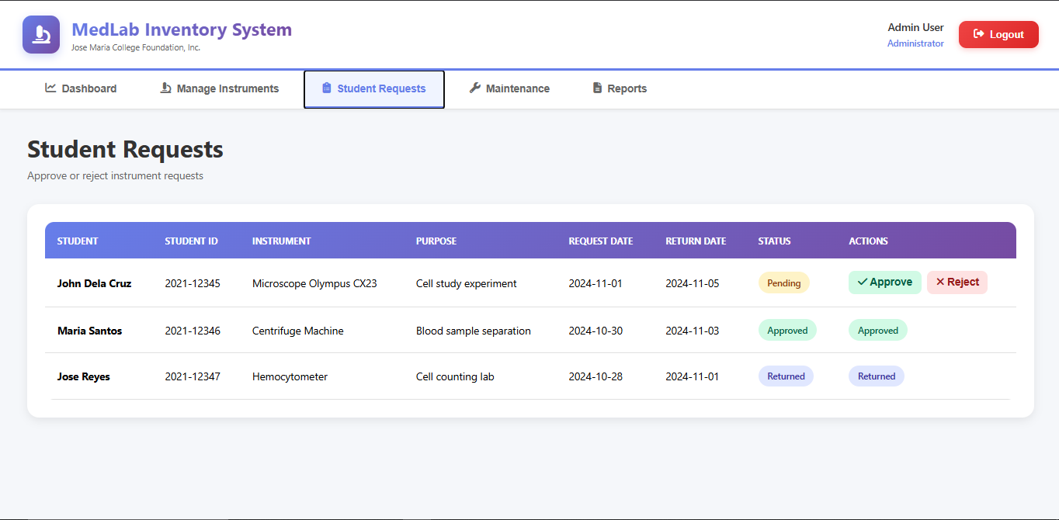
Figure 12.2 – Admin Panel: Approve Requests

This panel allows the administrator to review, approve, or reject instrument borrowing requests submitted by users.

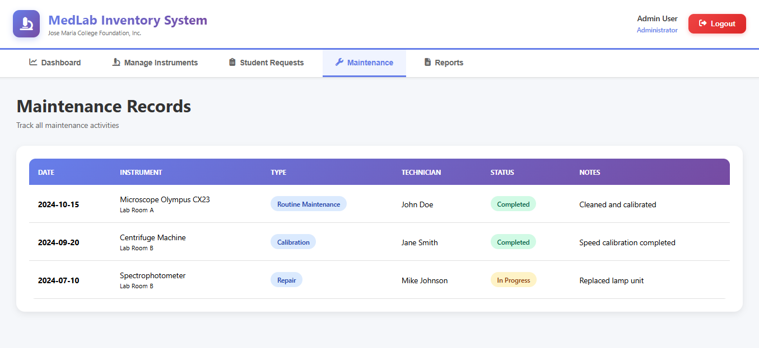Figure 12.3 – Admin Panel: System Maintenance

Handles system backup, data updates, check conditions and overall system maintenance.

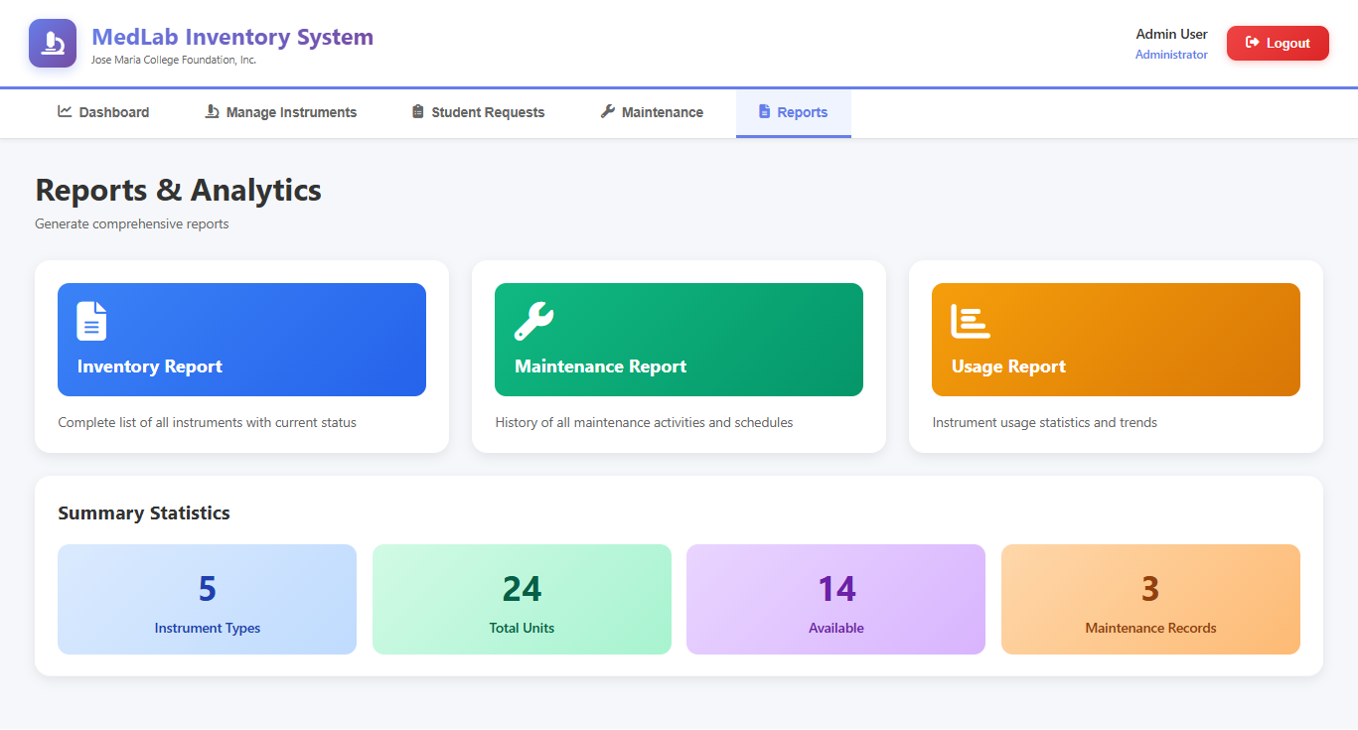
Figure 12.4 – Admin Panel: Reports

Generates summaries of borrowed, returned, and approved instruments.

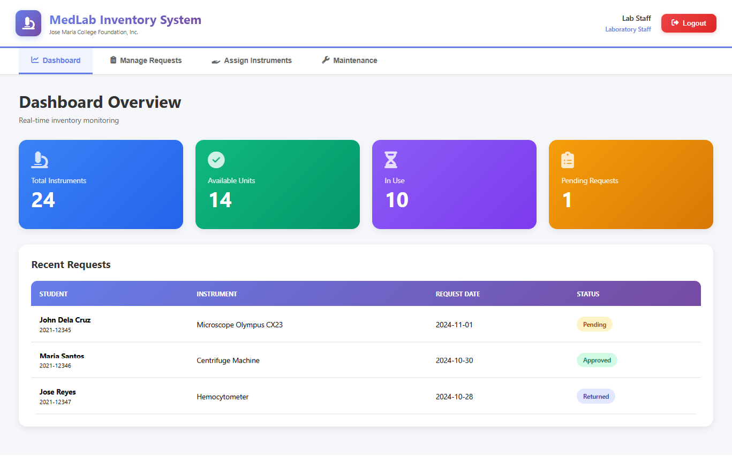
Figure 13.0 – Staff Dashboard

The staff dashboard displays instrument status and request updates, allowing staff to monitor and manage instrument distribution.

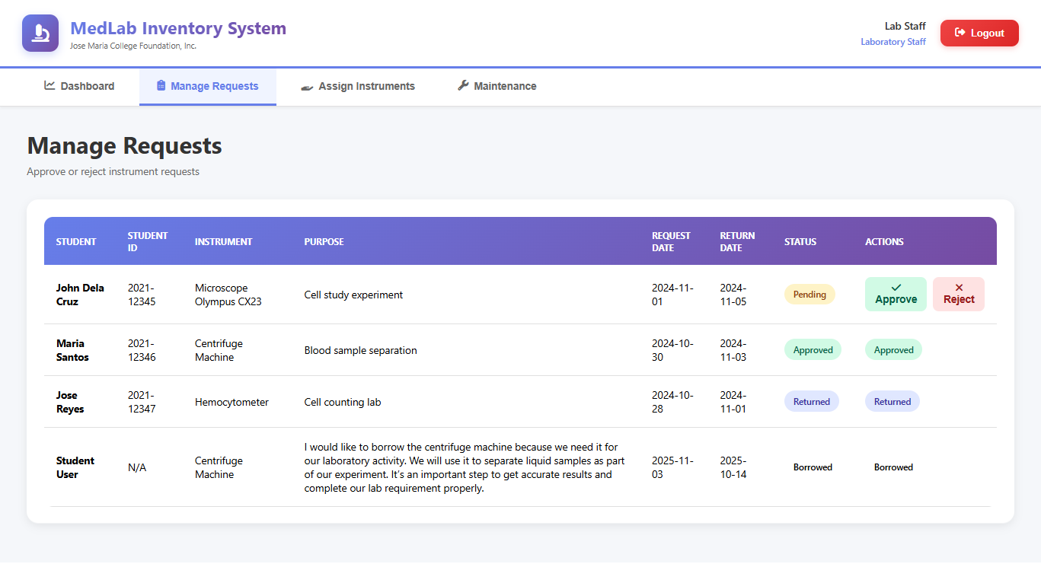
Figure 13.1 – Staff Panel: Manage Requests

Logs the approval and return of instruments.

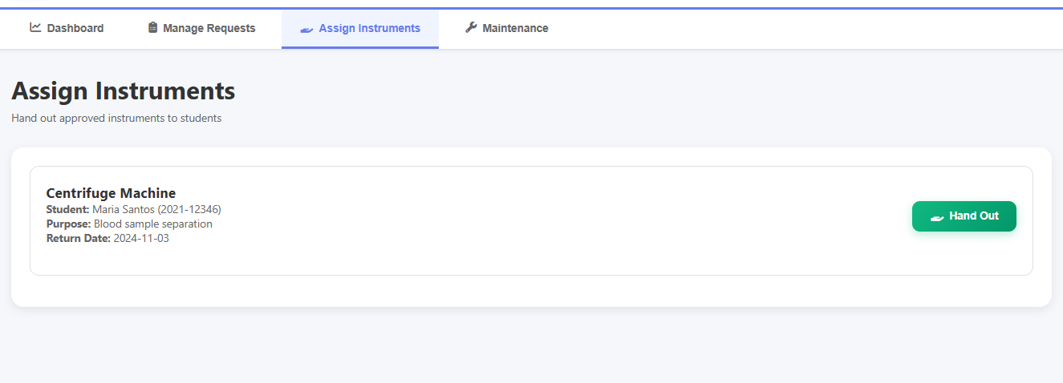
Figure 13.2 – Staff Panel: Hand Out Instrument
Records the release of instruments to students after admin approval.

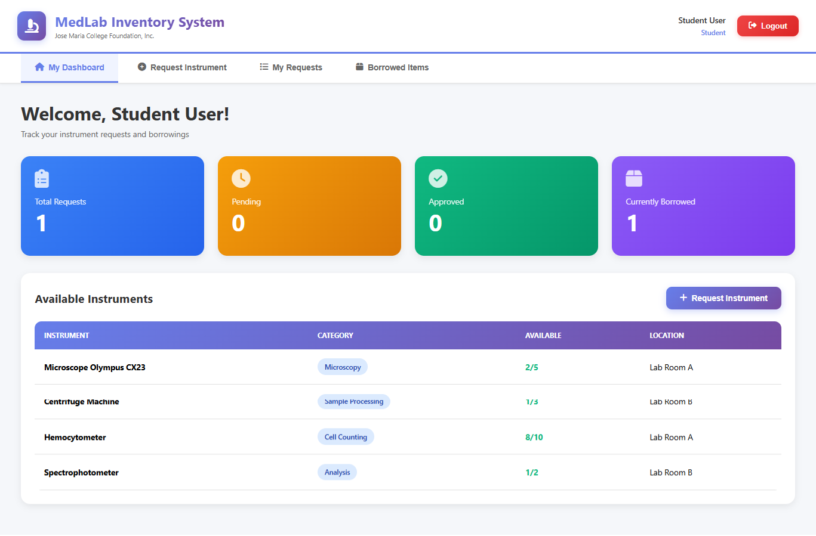
Figure 14.0 – Student Dashboard
Displays available instruments and current borrowing status.
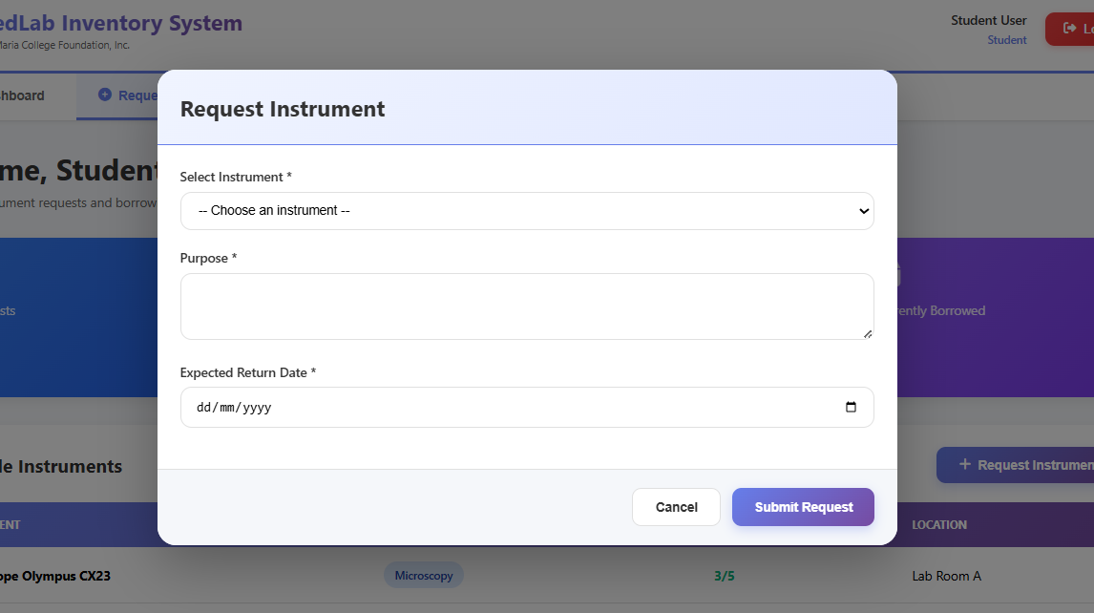
Figure 14.1 – Student Panel: Request Instrument

Enables students to request instruments needed for laboratory use.

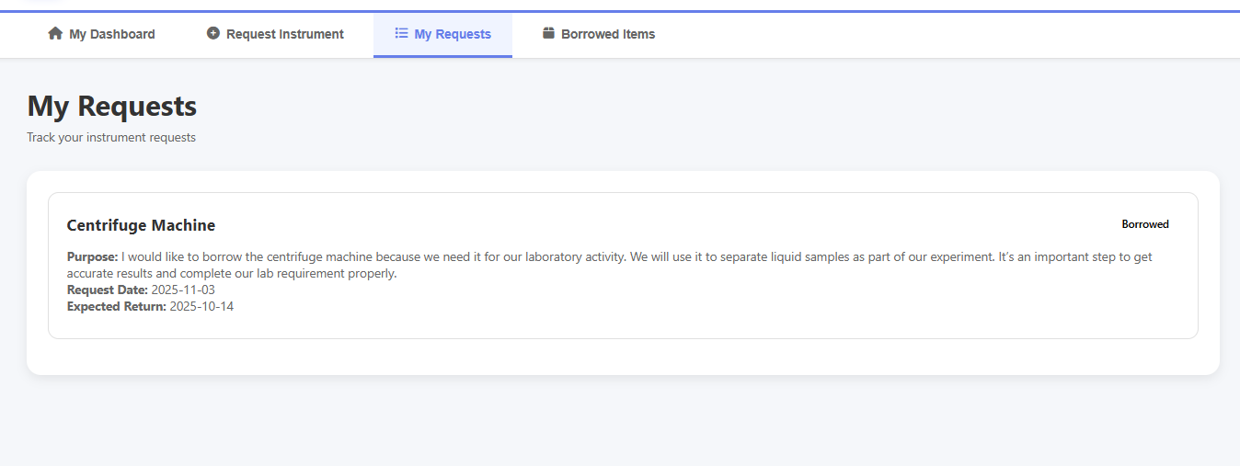
Figure 14.2 – Student Panel: My Request Panel
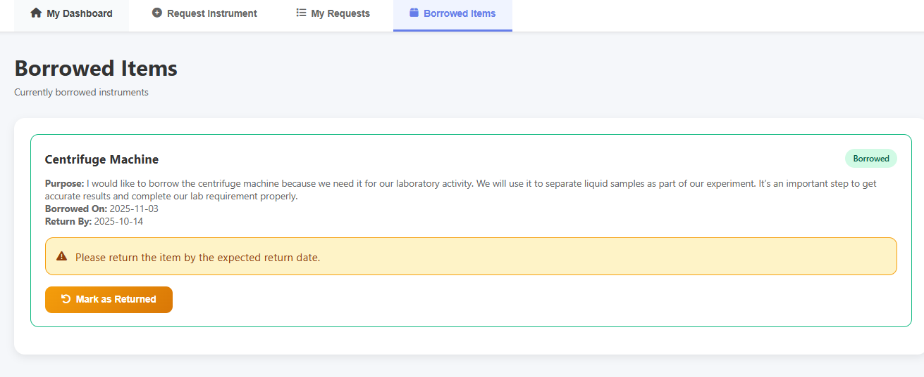
Figure 14.3 – Student Panel: Borrowed Item Details

Lists details of borrowed instruments, including issue and return date

23. Integration Implementation
All modules are connected through shared access to the central MySQL database.
When a user performs an action (e.g., adding, borrowing, or updating), the system updates the corresponding table automatically.
For future improvement, the system can integrate:
- Email Notification API for request approvals or due returns.
- Cloud Backup API for automated data backups.
24. Tools and Platforms

Category | Tool/Platform
IDE | Flutter
Version Control | GitHub
Local Server | XAMPP (Apache & MySQL)
Scripting Language | PHP
Design Tool | HTML CSS JS
Operating Environment | Windows 10 / Localhost Deployment
Table 2.0 Tools and Platforms
25. REFERENCES

Pirta, R., & Grabis, J. (2015). Integrated Methodology for information system change control based on enterprise architecture models. Information Technology and Management Science, 18(1). https://doi.org/10.1515/itms-2015-0016

Anade, M. a. M., Calibo, C. T. C., Noveda, J. P., Yu, W. R., & Verecio, R. L. (2024). Leyte Normal University: Supply Inventory Management System. Zenodo. https://doi.org/10.5281/zenodo.10007939

View of Design and implementation of a Web-Based Laboratory Management System for Efficient Resource Tracking. (2024.). https://www.ajesjournal.org/index.php/ajes/article/view/4248/7633

Abude, A. R. (2021). Laboratory Information Management System. Bureau of Solis and Water Management. https://www.google.com/url?q=https://www.bswm.da.gov.ph/laboratory-information-management-system/&sa=D&source=docs&ust=1763022036993711&usg=AOvVaw2W8MykLgynQA5nSaU1f2fB

